Gmeet Clone

Lec 2. Create folder structure

* Create the folder and from source folder import all the files
* After doing this make two html files
* Import your folder in VS Code
* Now open the new terminal and write down
* npm init
* After doing this press enter
* Then install socket.io
* 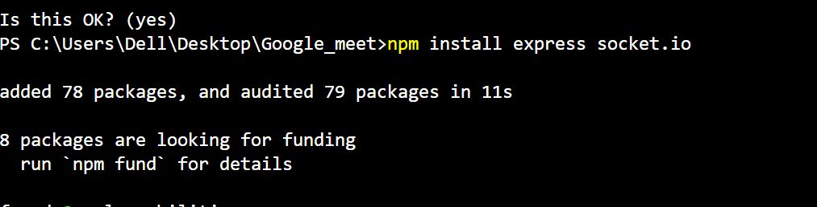
* So as we do this the various files are added
* 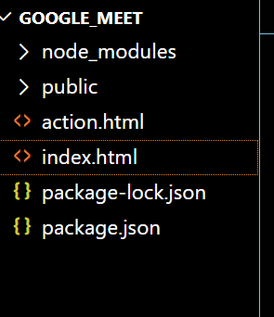
* All the node_modules are added
* Now in package.json edit the below
* 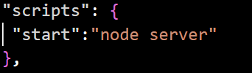
* This means whenever In terminal I write npm * then command will run server.js file
* For this we also need to make a file called as server.js